Triangulating your Design
Triangulating your design is not an explicit part of UML; however it is a process you need to apply to make sure that your documentation is internally consistent. Each UML document views your system from different angles. Imagine drawing pictures of a house. You might stand in the back garden and draw the house from there. If the house has a chimney you will need to make sure the chimney is included. If you then draw a picture from the front of the house and omit the chimney when it is clearly visible then comparing the two pictures would help to spot the discrepancy.
The same is true of the three UML documents. If in your use case diagram you have an actor called admin who never appears on any of the sequence diagrams then something has been missed. If there is an object on your sequence diagram that lacks a class on the class diagram then you need to review the design.
This document contains sample diagrams and triangulation data for the address book application. The first part of the document contains candidate design documents for the design of the system. The second part of the system has potential triangulation data for the described system. There are gaps in both the diagrams and the triangulation data and as an exercise you will be required to try and identify the gaps. The third part of the document contains blank triangulation tables so that you may apply the technique to your own system design.

Contents
Part 1: Sample Diagrams 1
Part 2: Triangulation Tables 5
Actors 5
Use Cases 5
Classes and Objects 5
Part 3: Blank Tables 8
Actors 8
Use Cases 8
Classes and Objects 9

Part 1: Sample Diagrams

Use Case Diagram
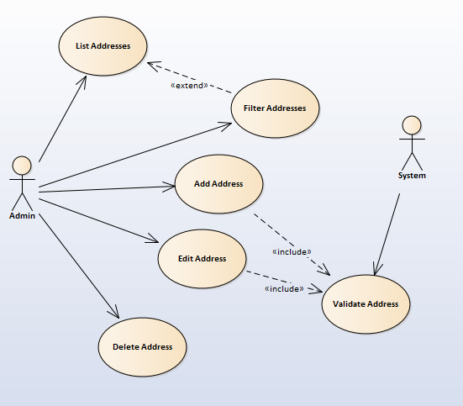

Adding Address Records
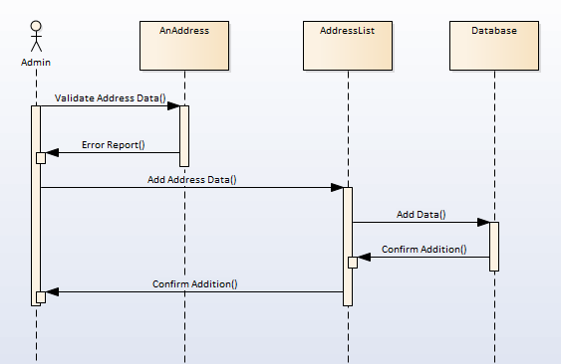

Deleting Address Records
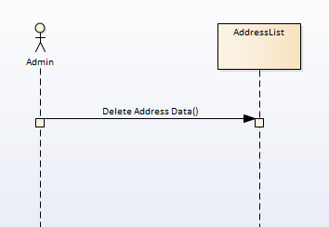

Updating Address Records
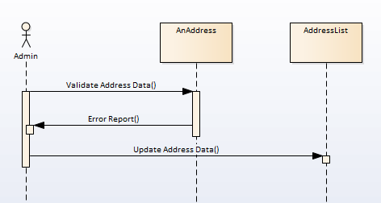

Address Listing and Filtering
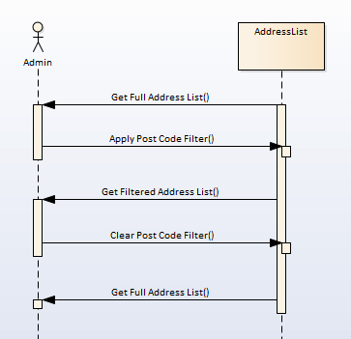

Class Diagram
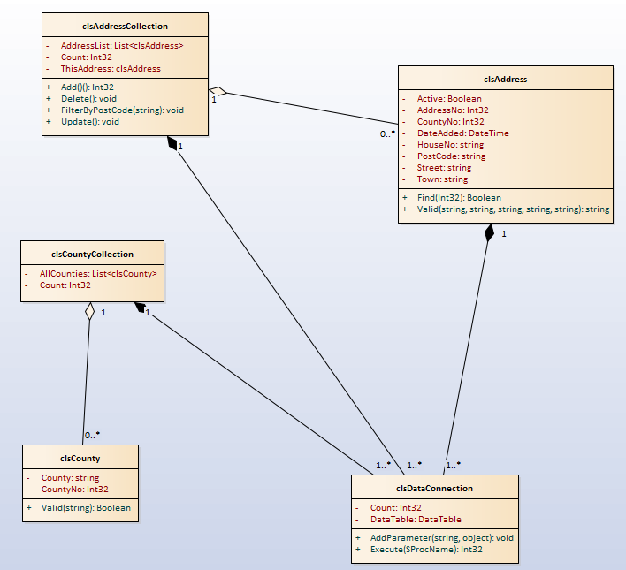

Part 2: Triangulation Tables

Actors
List below all matching actors in your use case diagrams and your sequence diagrams
Use Case Actors | Sequence Diagram Actors
Admin | Admin
System | NA

Use Cases
List each use-case in your use-case diagram along with its associated sequence diagram(s).
Use Cases on Use Case Diagram | Associated Sequence Diagram
List Addresses | Address Listing and Filtering
Filter Addresses | Address Listing and Filtering
Add Address | Adding Address Records
Edit Address | Updating Address Records
Delete Address | Deleting Address Records
Validate Address | Adding Address Records/Updating Address Records

Classes and Objects
List all classes in your class diagram along with matching objects in your sequence diagram. Across all sequence diagrams each messages to/from your object must be handled by some feature of your class design.
Class Name | clsAddress
Object Name | AnAddress
Sequence Diagram | Messages for object | Handled in class by
Adding Address Records
 | Validate Address Data | Valid method
 | Error Report | Valid method return data
Updating Address Records
 | Validate Address Data | Valid method
 | Error Report | Valid method return data

Class Name | clsAddressCollection
Object Name | AddressList
Sequence Diagram | Messages for object | Handled in class by
Adding Address Records
 | Add Address Data | Add method
 | Confirm Addition | Add return data
Updating Address Records
 | Update Address Data | Update method
Deleting Address Records
 | Delete Address Data | Delete method
Address Listing and Filtering
 | Get Full Address List | Address List collection
 | Apply Post Code Filter | FilterByPostCode
 | Get Filtered Address List | Address List collection
 | Clear Post Code Filter | FilterByPostCode

Class Name | clsDataConnection
Object Name | Database
Sequence Diagram | Messages for object | Handled in class by
Adding Address Records | Add Data | Add Parameter / Execute Methods
 | Confirm Addition | Execute method return value

Part 3: Blank Tables

Actors
List below all matching actors in your use case diagrams and your sequence diagrams
Use Case Actors | Sequence Diagram Actors

Use Cases
List each use-case in your use-case diagram along with its associated sequence diagram(s).
Use Cases on Use Case Diagram | Associated Sequence Diagram

Classes and Objects
List all classes in your class diagram along with matching objects in your sequence diagram. Across all sequence diagrams each messages to/from your object must be handled by some feature of your class design.
Class Name
Object Name
Sequence Diagram | Messages for object | Handled in class by

